Name: Astha Arpit Bhatt

Enroll: 196140316006

**Practical 9**

Aim :- Create an application that displays a frame with a menu bar. When a user selects any menu or menu item, display that selection on a text area in the center of the frame.

Code:

import java.awt.*;

import java.awt.event.*;

import java.applet.*;

/*<applet code="pra9.class" height=500 width=500></applet>*/

public class pra9 extends Applet implements ActionListener

{

Frame f;

Label l;

public void init()

{

f = new Frame("Menu Demo");

l = new Label("Select any MenuItem from File Menu");

MenuBar mb = new MenuBar();

Menu mn = new Menu("File");

MenuItem mi1 = new MenuItem("New");

mi1.addActionListener(this);

MenuItem mi2 = new MenuItem("Open");

mi2.addActionListener(this);

MenuItem mi3 = new MenuItem("Save");

mi3.addActionListener(this);

MenuItem mi4 = new MenuItem("Close");

mi4.addActionListener(this);

mn.add(mi1);

mn.add(mi2);

mn.add(mi3);

mn.add(mi4);

mb.add(mn);

f.setMenuBar(mb);

f.setLayout(new FlowLayout());

f.add(l);

f.setSize(300,300);

f.setVisible(true);

}

public void actionPerformed(ActionEvent o)

{

if(o.getSource() instanceof MenuItem)

{

l.setText(o.getActionCommand());

}

}

}

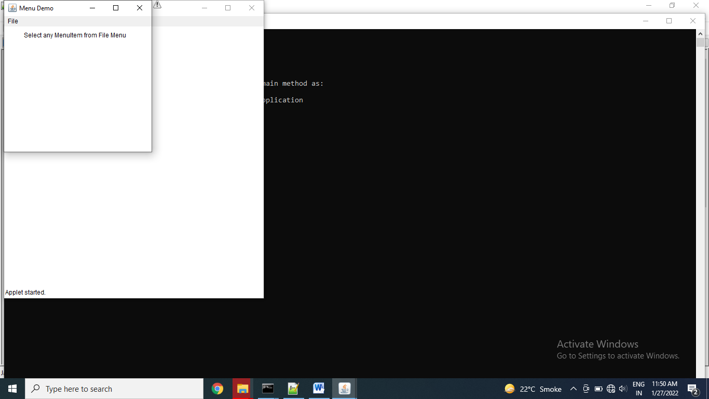

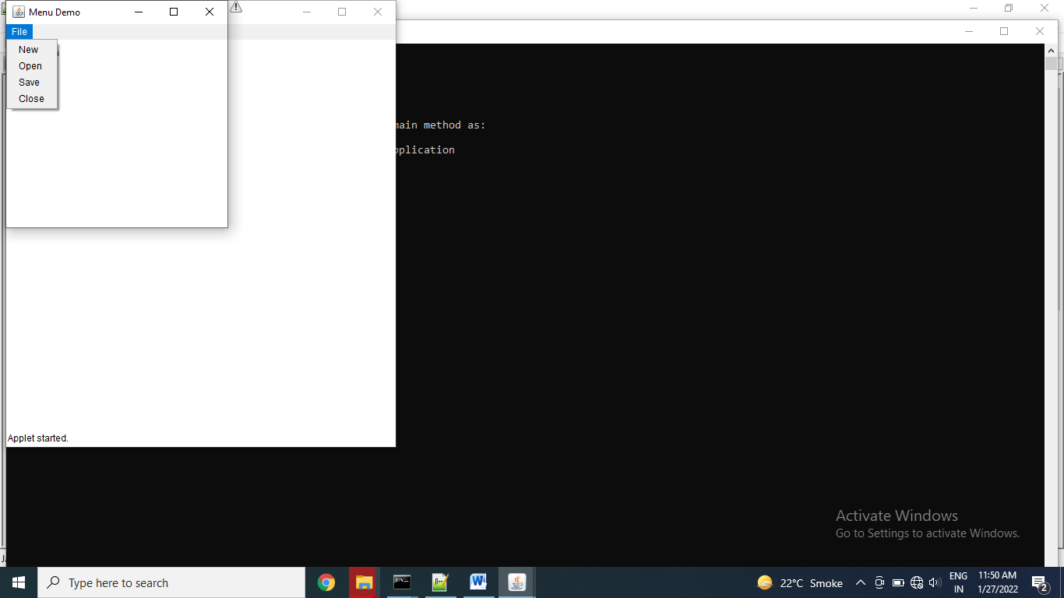

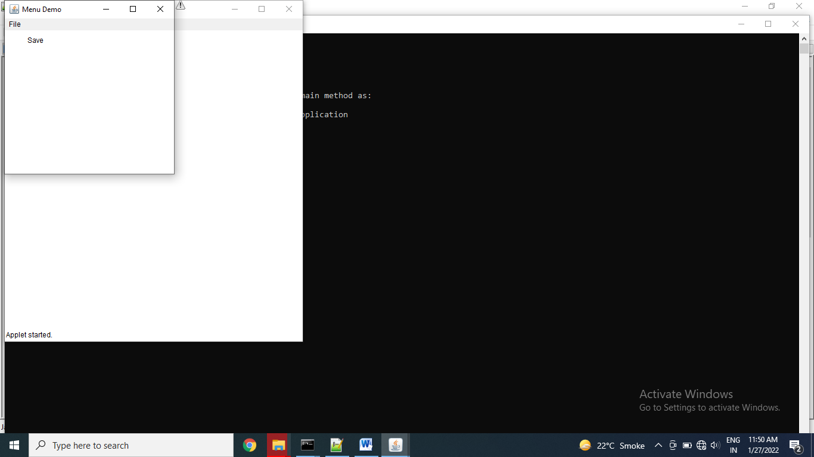

Exercise:

Create a screen with three menus with minimum 2 sub menu’s in each.

import java.awt.*;

public class pra9e1

{

Frame f;

public pra9e1()

{

f=new Frame("Practical of Menu");

// l.setBounds(50,50,10,10);

MenuBar mb=new MenuBar();

Menu mn=new Menu("File");

Menu mn1=new Menu("New");

MenuItem e1=new MenuItem("Item 1");

MenuItem e2=new MenuItem("Item 2");

MenuItem mi2=new MenuItem("Open");

MenuItem mi3=new MenuItem("Save");

Menu mn4=new Menu("Exit");

MenuItem e3=new MenuItem("Item 3");

mn4.setActionCommand("I am exit command");

mn.add(mn1);

mn1.add(e1);

mn1.add(e2);

mn.add(mi2);

mn.add(mi3);

mn.add(mn4);

mn4.add(e3);

mb.add(mn);

// f.setMenuBar(mb);

Menu mn2=new Menu("Edit");

MenuItem mn21=new MenuItem("Cut");

Menu mn22=new Menu("Copy");

MenuItem e4=new MenuItem("Item 4");

Menu mn23=new Menu("Paste");

MenuItem e5=new MenuItem("Item 5");

MenuItem mn24=new MenuItem("Undo");

mn2.add(mn21);

mn22.add(e4);

mn2.add(mn22);

mn23.add(e5);

mn2.add(mn23);

mn2.add(mn24);

mb.add(mn2);

Menu mn3=new Menu("Design");

Menu mn31=new Menu("Font");

MenuItem e6=new MenuItem("Times New Roman");

MenuItem e7=new MenuItem("Dancing script");

MenuItem mn32=new MenuItem("Syntax");

MenuItem mn33=new MenuItem("Size");

Menu mn34=new Menu("Color");

MenuItem e8=new MenuItem("Black");

MenuItem e9=new MenuItem("Blue");

MenuItem e10=new MenuItem("White");

mn31.add(e6);

mn31.add(e7);

mn3.add(mn31);

mn3.add(mn32);

mn3.add(mn33);

mn34.add(e8);

mn34.add(e9);

mn34.add(e10);

mn3.add(mn34);

mb.add(mn3);

f.setMenuBar(mb);

f.setSize(500,500);

f.setVisible(true);

}

public static void main(String args[])

{

pra9e1 ob=new pra9e1();

}

}

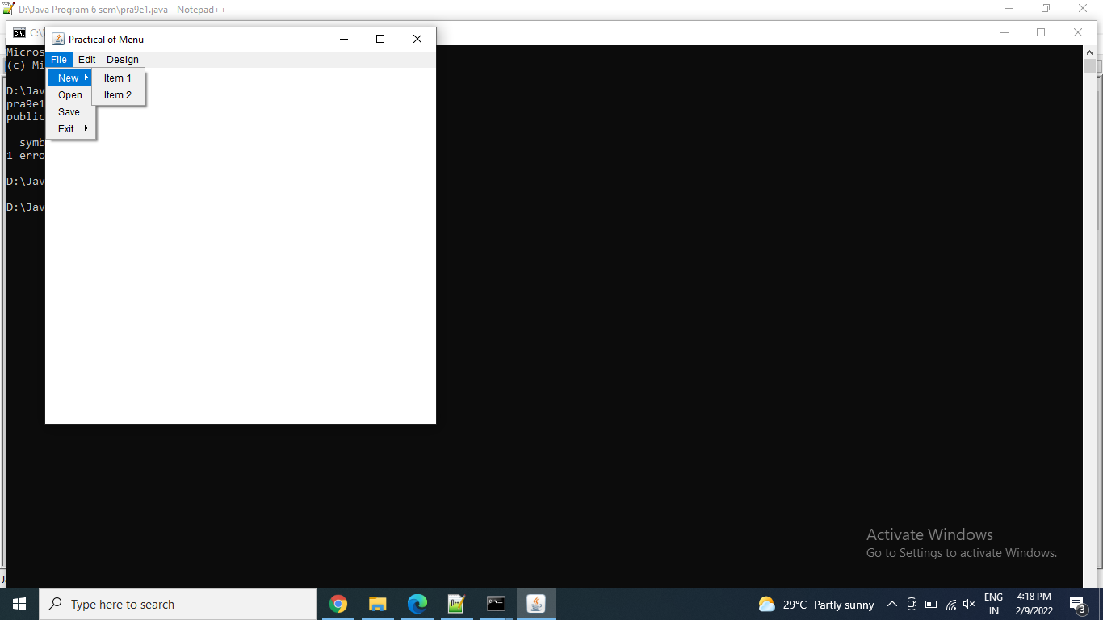

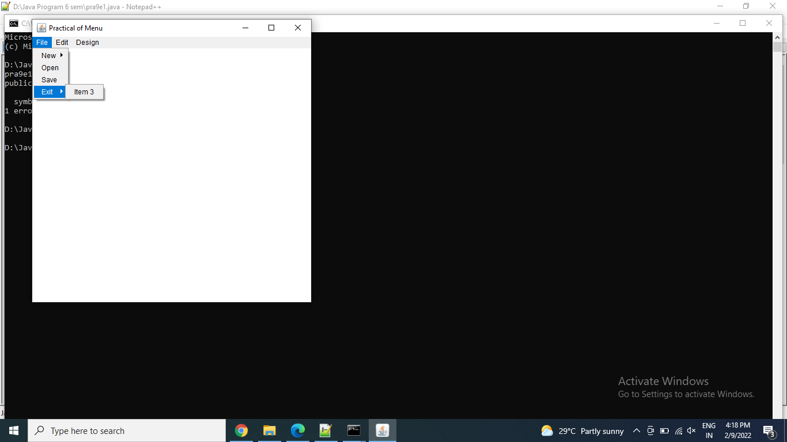

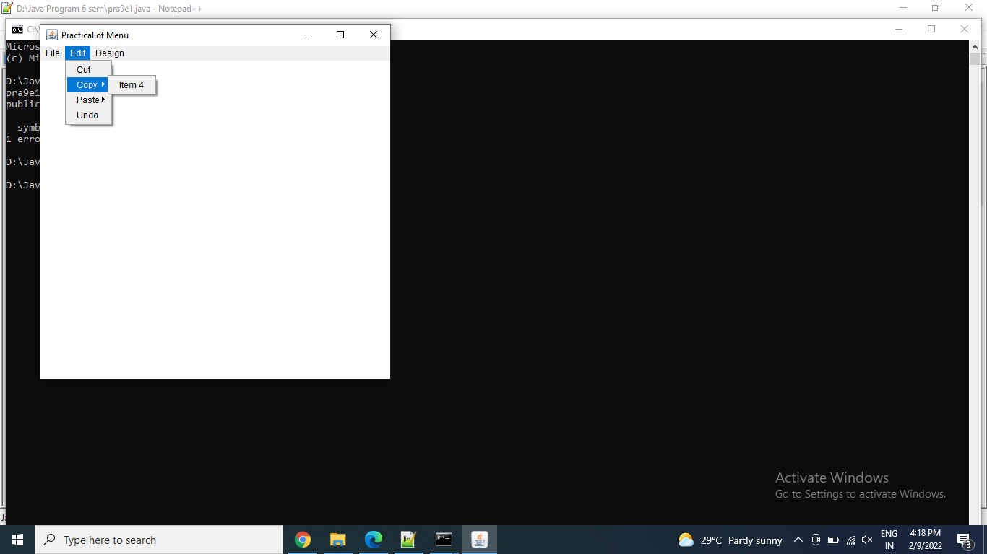

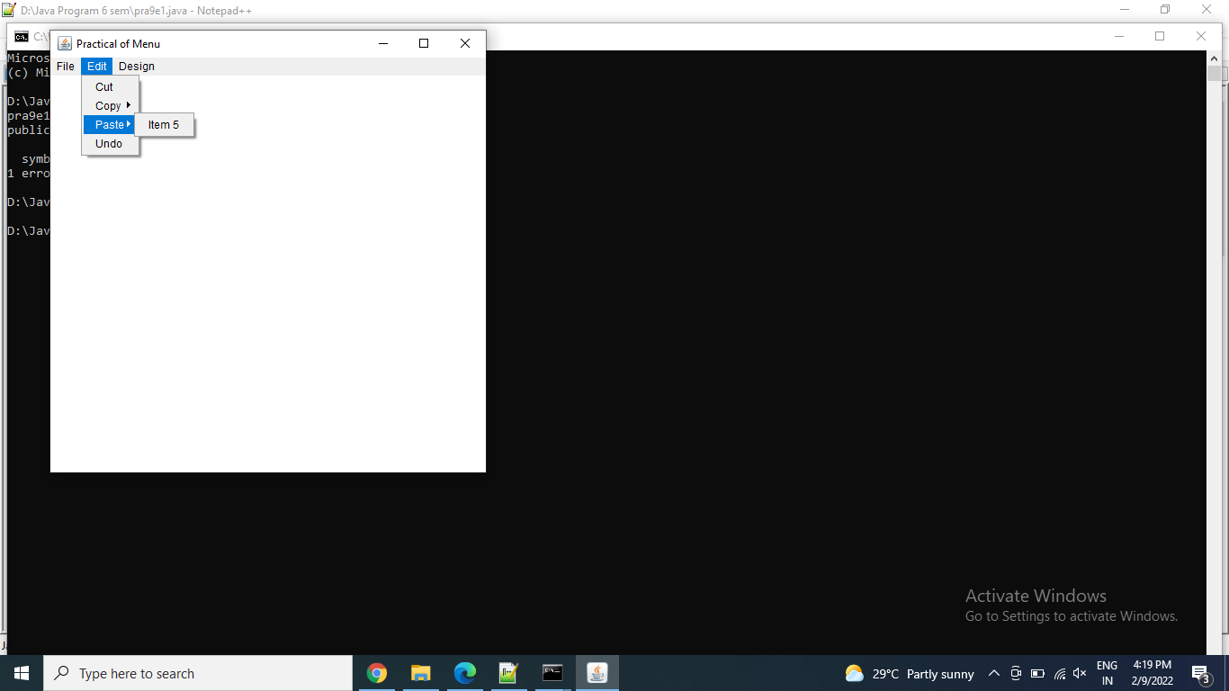

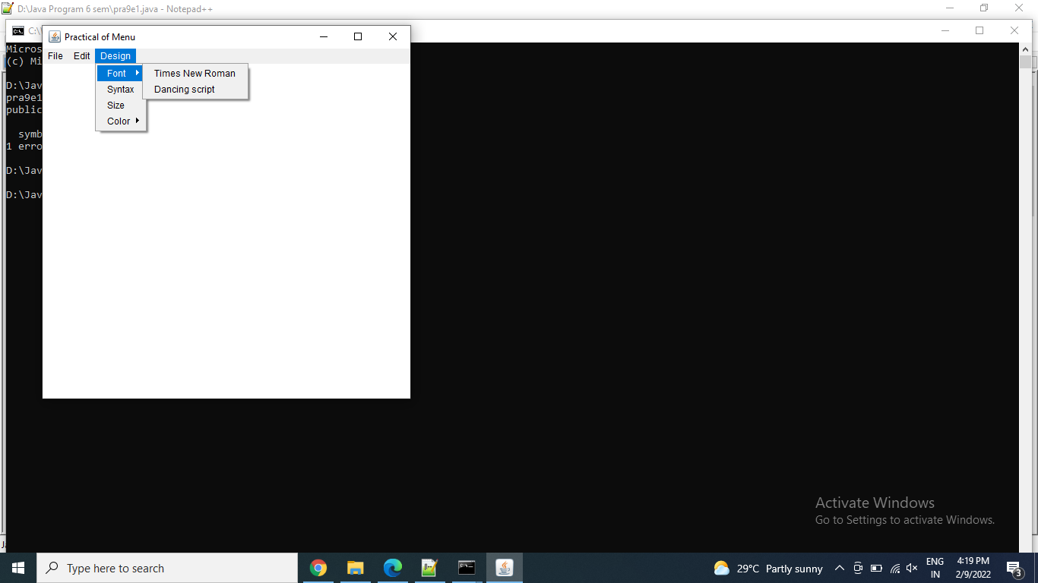

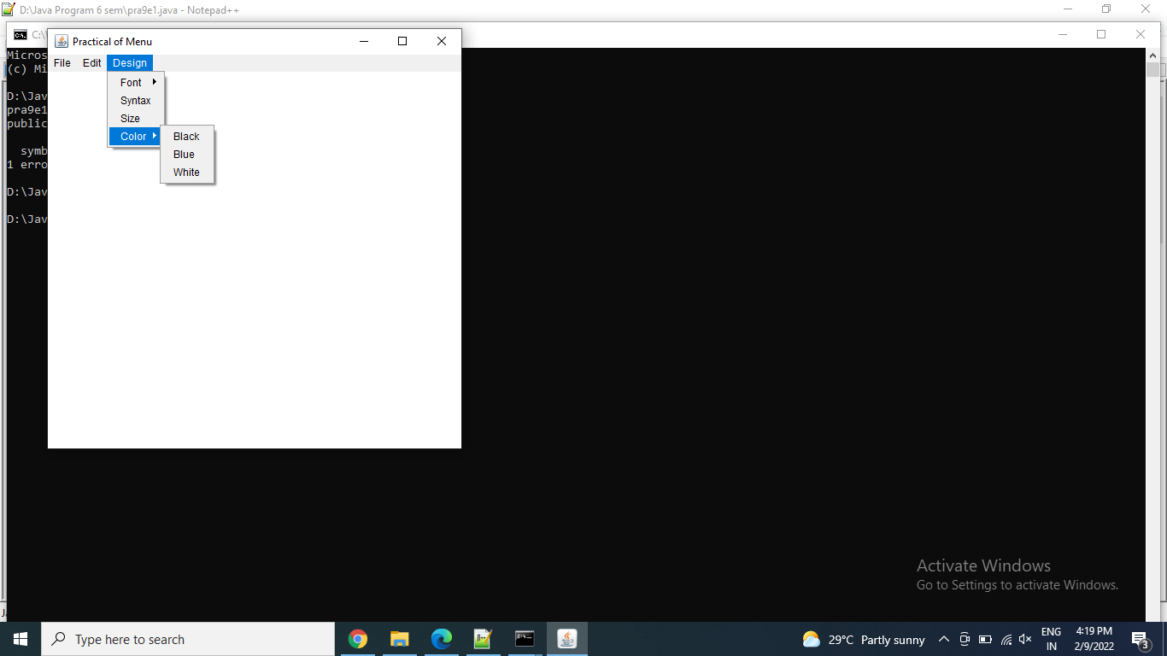

Thanks mam!!